Experiment: 7
Analog Beamforming Analysis Using MATLAB
P.VENKATA KISHORE
192412581

Objectives 1. To analyze the beamforming gain achieved by varying the number of antenna elements in an analog beamforming system using MATLAB.
MATLAB CODE:
clc;
clear;
close all;
antennas = [2 4 8 16 32];
gain = 10*log10(antennas);
figure
bar(antennas, gain)
grid on
% Number of Antenna Elements
% Beamforming Gain (dB)
xlabel('Number of Antenna Elements')
ylabel('Beamforming Gain (dB)')
title('Beamforming Gain for Different Antenna Array Sizes')

OUTPUT:
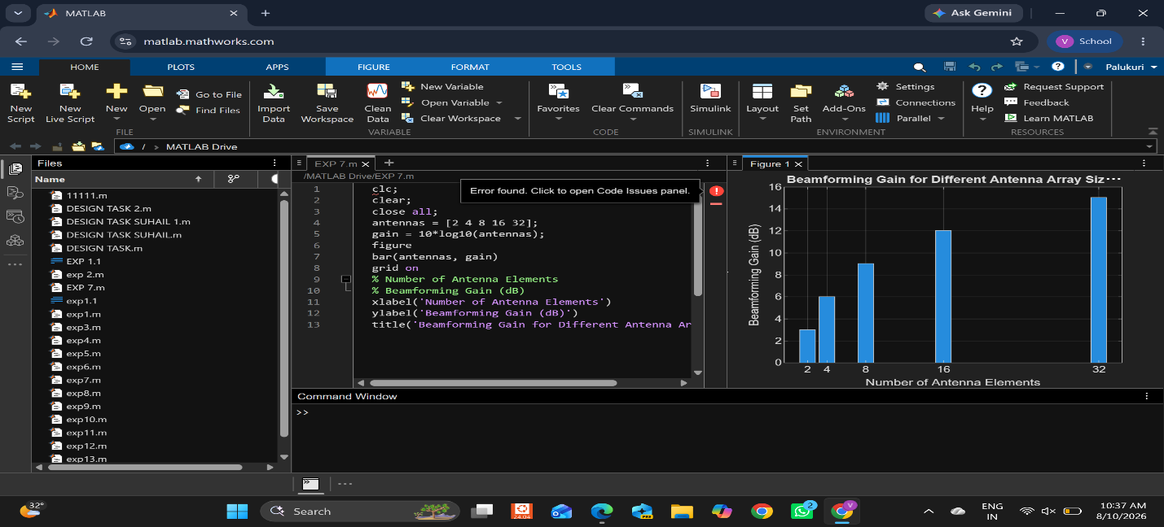

Objective – 2:
To compare the beam width of an antenna array for different beamforming configurations using MATLAB. MATLAB CODE:
clc;
clear;
close all;
antennas = [2 4 8 16 32];
% Number of Antenna Elements
beamwidth = [90 45 22.5 11.25 5.625];
figure
% Beam Width (degrees)
plot(antennas, beamwidth,'o-','LineWidth',2)
grid on
xlabel('Number of Antenna Elements')
ylabel('Beam Width (Degrees)')
title('Beam Width for Different Antenna Array Sizes')

OUTPUT:
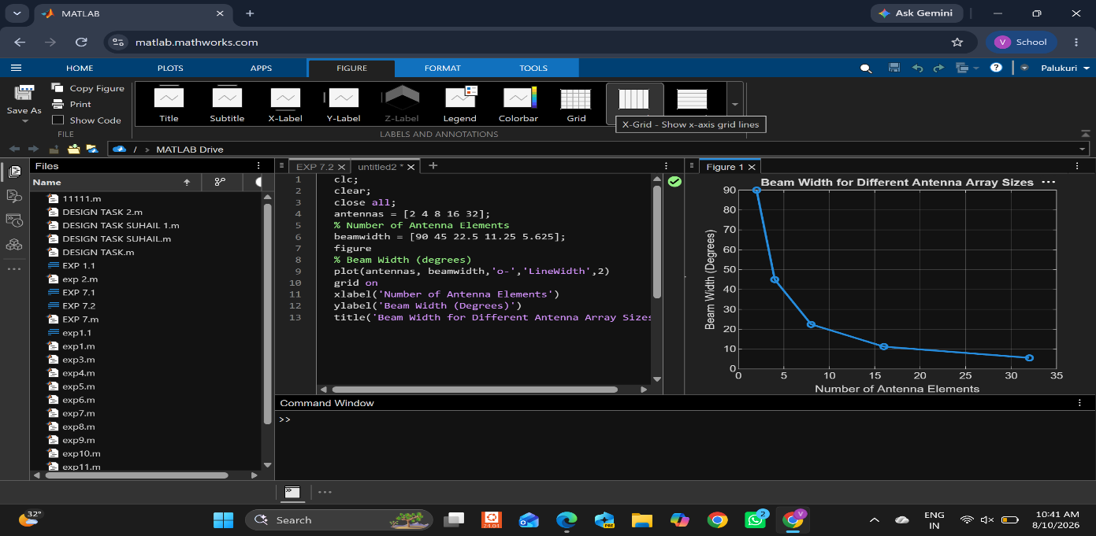

Objectives:3:
To analyze the main lobe direction by steering the antenna array beam to different angles using MATLAB.

MATLAB CODE:

clc;
clear;
close all;
theta = [-60 -30 0 30 60];
gain = [1 1 1 1 1];
figure
% Main Lobe Direction (degrees)
% Constant normalized gain
polarplot(deg2rad(theta), gain, 'o', 'LineWidth', 2)
title('Main Lobe Direction in Analog Beamforming')

OUTPUT: 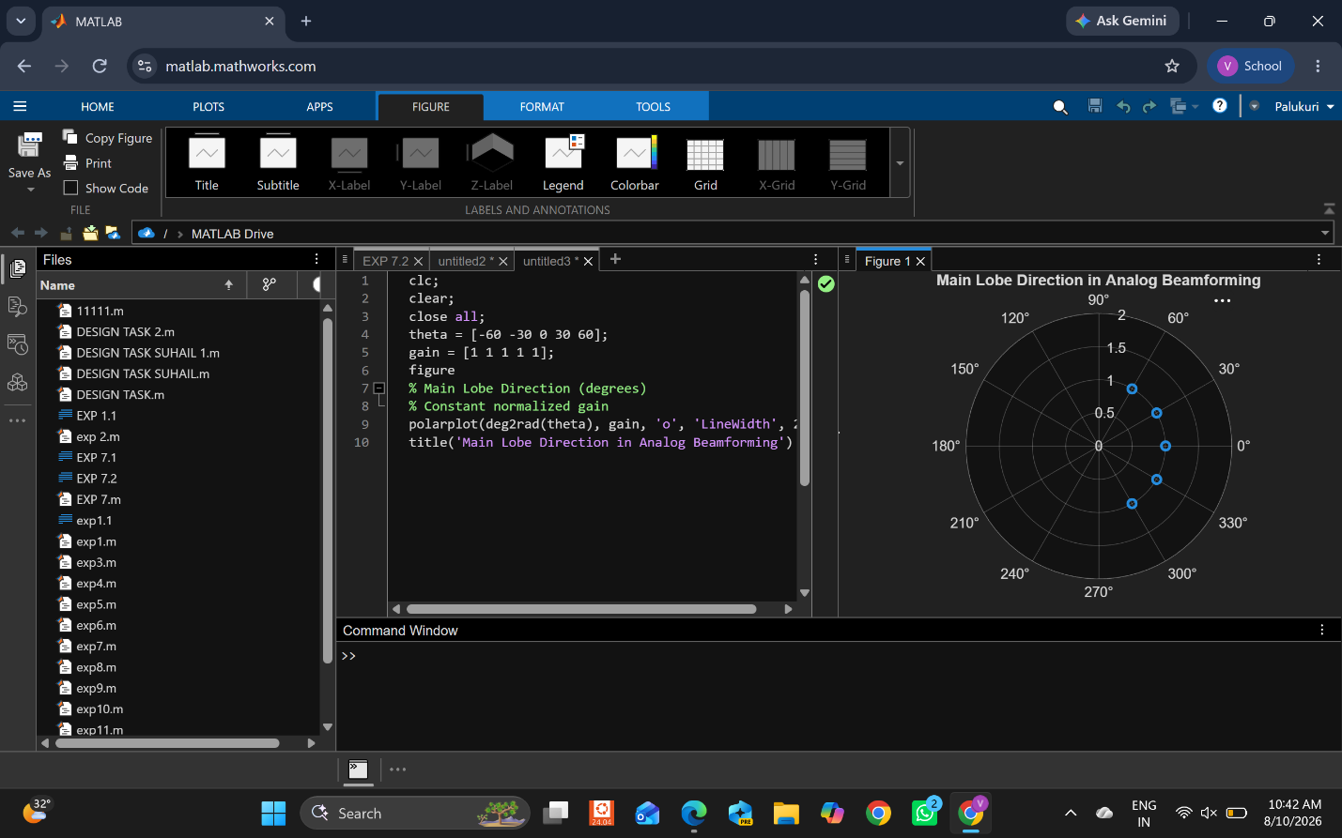

Result:
The MATLAB analysis successfully demonstrated the characteristics of analog beamforming. The results showed that increasing the number of antenna elements improves beamforming gain and reduces beam width, while phase adjustment enables the main lobe to be steered toward different directions.

